# You don’t have permission to access ‘URL’ on this server

## The Final and Real Fix

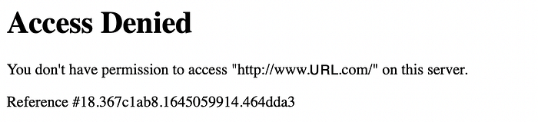

# Table of Contents

1. [Introduction](https://medium.com/@rogernem/you-dont-have-permission-to-access-url-on-this-server-c81430225c0e#5516)
2. [What is MAC cloning?](https://medium.com/@rogernem/you-dont-have-permission-to-access-url-on-this-server-c81430225c0e#96e2)
3. [Why clone a MAC address?](https://medium.com/@rogernem/you-dont-have-permission-to-access-url-on-this-server-c81430225c0e#f7f8)
4. [Solution](https://medium.com/@rogernem/you-dont-have-permission-to-access-url-on-this-server-c81430225c0e#47d6)  
   - [Step 1. Access the Management Page of the Router.](https://medium.com/@rogernem/you-dont-have-permission-to-access-url-on-this-server-c81430225c0e#ff48)  
   - [Step 2: Click on the “Advanced” tab.](https://medium.com/@rogernem/you-dont-have-permission-to-access-url-on-this-server-c81430225c0e#fac9)  
   - [Step 3: Click on “Internet” under the Network section.](https://medium.com/@rogernem/you-dont-have-permission-to-access-url-on-this-server-c81430225c0e#3101)  
   - [Step 4: Certify/Update Internet Connection Type and DNS Address.](https://medium.com/@rogernem/you-dont-have-permission-to-access-url-on-this-server-c81430225c0e#19c8)  
   - [Step 5: Certify/Update MAC Clone Configuration.](https://medium.com/@rogernem/you-dont-have-permission-to-access-url-on-this-server-c81430225c0e#d82b)  
   - [Step 6: Reboot the Router.](https://medium.com/@rogernem/you-dont-have-permission-to-access-url-on-this-server-c81430225c0e#5db6)  
   - [Step 7: Clear Cache and Cookies in Your Web Browser.](https://medium.com/@rogernem/you-dont-have-permission-to-access-url-on-this-server-c81430225c0e#2fc7)
5. [Success](https://medium.com/@rogernem/you-dont-have-permission-to-access-url-on-this-server-c81430225c0e#80d6)

# Introduction

When trying to browse “https://www.**certainURL**.com” on your home network you may get the “*You don’t have permission to access ‘URL’ on this server*” error message.

There could be a number of reasons this is happening and it can be frustrating not being able to access certain websites when you need them most.

But if when connected to a mobile carrier network (e.g. Verizon) you are able to browse the same URL and this only happens when connected to your home network (Ethernet or Wi-Fi), I will show in this article what to do to resolve this issue.

Many ‘solutions’ on the internet suggest this is due to one or a combination of what follows but most don’t provide the correct answer and the order certain steps must be executed to properly resolve this problem.

* Disabled the VPN Software: the issue happens without the use of any VPN
* Clear browser’s cache and cookies: this alone doesn’t resolve the problem.
* Use a different browser: this will not resolve the problem as people suggest to do this when their actual intentions are to do the above.
* Proxy servers: most users don’t have any proxy server configured and don’t make use of proxy in their browsers.
* Script/Software blocking URLs: also the case where most users don’t use any software to block sites, etc.
* Flush DNS: the issue in most cases are not caused by any DNS cache.
* Change DNS: this also doesn’t solve the problem.
* Disable Firewall: most users don’t use Firewalls and don’t have anything configured to block URLs.
* Disable Parental controls: again, this would not cause the issue for common URLs that would still get blocked (e.g. *www.google.com*)
* Resetting network configurations: it alone doesn’t resolve the problem.
* Resetting Modem configurations: this may cause even more problems and important configurations put in place might be lost.
* The ISP Provider is the one to blame: this will hardly ever be the case.
* Reinstalling Windows: this normally makes me laugh and will not resolve the problem.

Users desperate to resolve this problem try everything they can and eventually, by luck in most of the cases, come back saying “*doing X resolved my issue. Thanks*“.

But what they don’t understand is that to actually resolve this issue one must take the correct actions and do them in the correct order.

Furthermore, if the same users come to face this issue again they might not be able to resolve it this time around, simply because they might execute these actions in different order.

So let’s start by clarifying what actually causes this problem, by answering the two questions below:

# What is MAC cloning?

In order to understand MAC cloning, it’s important to know what it stands for. The abbreviation MAC stands for Media Access Control and the hardware address is what the device, or Network Interface Card, is manufactured with.

Every network-enabled device has a unique MAC address. Like an IP address, a MAC address is a unique identifier for a device. However, unlike an IP address, a device technically receives only one MAC address during its lifetime. MAC cloning is, as the name implies, the process of replicating a device’s MAC address and assigning it to another device.

# Why clone a MAC address?

MAC address cloning is most helpful in fixing network or connectivity problems. Computer or device connectivity issues happen even with the hardware and software working properly. MAC cloning can generally fix this. However, when you add a different computer or device that has its own MAC address, such as a router, connectivity issues to your ISP may arise. By simply cloning the MAC address from the previous router that the ISP has used for assigning IP addresses could resolve the connectivity issue.

Provided that it has the capability, MAC cloning is solely done at the router level. Most ISPs assign their IPs based on the MAC address in your equipment. If the MAC address of your router is AA–BB–CC–33–44–55 and you connect to your ISP, the DHCP server records your MAC and assigns an IP.

If you disconnect from the ISP, you lose your IP address. Therefore, the next time you connect, the DHCP server sees your MAC. It also looks to see if it has assigned an IP address to you before.

If it has assigned an IP and the lease time has not expired, it will most likely give you the same IP address you had before disconnecting. A new MAC address most likely equals a new IP address, too.

**Essentially, MAC cloning helps “non-approved” devices access the network**. If you tell your router to clone your network card’s MAC, it makes your ISP think that you’re still using the same computer, network card, or device to access their services. Therefore, they allow your router on the network.

MAC address cloning is used because some ISP don’t want you to have a router connected to the modem.

# Solution

The instructions below are provided for TP-Link Routers but it can be used for other routers as well.

TP-Link routers feature a built-in web-based management utility. This internal web server does not require the router to have internet access. It does however **require your device to be connected to the** TP-Link **router’s network**.

This connection can either be **wired** or **wireless** and can be accessed via any device with a web browser like a desktop computer, a phone, tablet, iPad, etc.

## Step 1. Access the Management Page of the Router.

* If **Wireless:** Make sure your client device is connected to your router’s wireless SSID (*if using the Defaults, the SSID and Password are printed on your router label*).

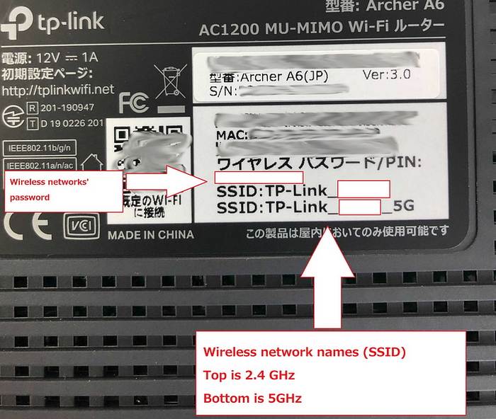

* If **Wired:** Connect your client to your router via Ethernet cable to one of the **LAN ports** (Yellow) on the back of your TP-Link router.

Launch/open a web browser and enter <http://tplinkwifi.net> or <http://192.168.0.1> in the address bar.

One of the two types of login pages may pop-up for the first time:

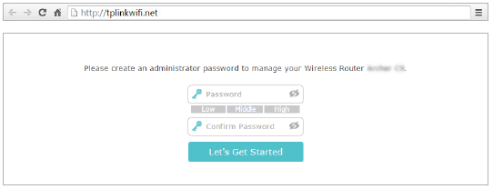

— requiring you to create an administrator password.

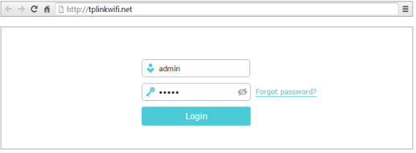

— requesting a username and password (by default, these are both the word ‘admin’ all lower case).

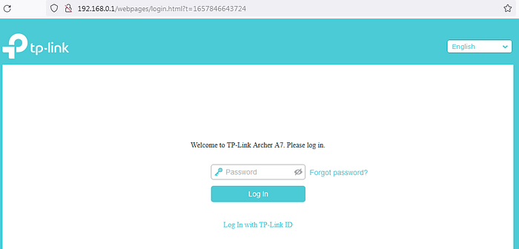

## Step 2: Click on the “*Advanced*” tab.

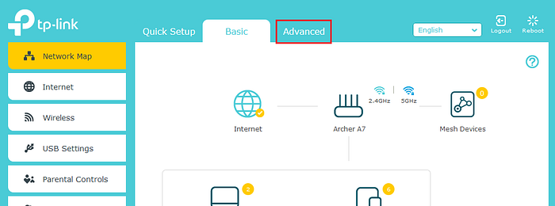

## Step 3: Click on “Internet” under the Network section.

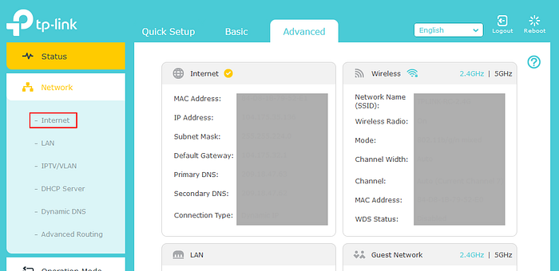

## Step 4: Certify/Update Internet Connection Type and DNS Address.

Under IPv4, make sure the “**Internet Connection Type**” is set to “***Dynamic IP”*** and that “**DNS Address”** is set to “***Get dynamically from ISP***” under Advanced.

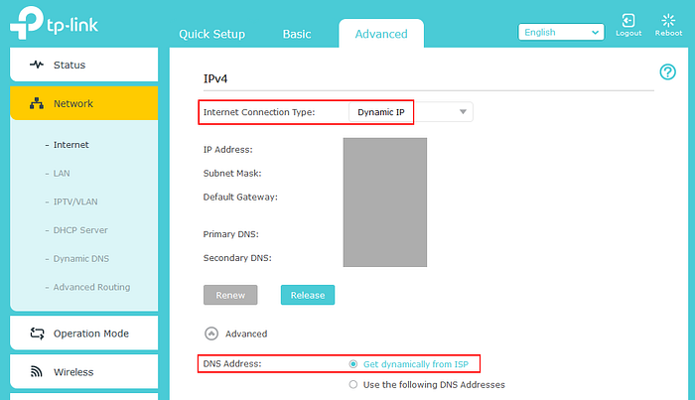

## Step 5: Certify/Update MAC Clone Configuration.

Also, on the same page, under “**MAC Clone**”, make sure “**Use Default MAC Address**” is selected.

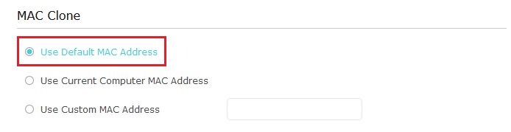

Your router has at least two ports, one for the WAN (the “internet”, so to say) and one for your (W)LAN, i.e. the internal network. Both have two different MAC addresses. By assigning your router the MAC address of your computer, they don’t have the same MAC in your LAN, but the router will “copy” the MAC address to its WAN port, therefore appearing to your ISP like it was your computer.

## Step 6: Reboot the Router.

Once the above is certified/done, reboot the router by clicking on “Reboot”.

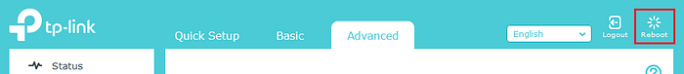

Wait until the router is fully rebooted. You will lose connectivity temporarily, but you should be able to be re-connected once the process completes.

**Step 7: Clear Cache and Cookies in Your Web Browser.**

Now is the time to clear the cache and cookies of your web browser to ensure “the bad data” is not served to you but instead the fresh version is downloaded from the source server and rendered by your browser.

* [Chrome Instructions](https://support.google.com/accounts/answer/32050?hl=en&co=GENIE.Platform%3DDesktop)
* [Firefox Instructions](https://support.mozilla.org/en-US/kb/how-clear-firefox-cache)
* [Microsoft Edge Instructions](https://www.microsoft.com/en-us/edge/learning-center/how-to-manage-and-clear-your-cache-and-cookies?form=MA13I2)
* [Safari Instructions](https://support.apple.com/en-us/105082)

# Success

After the above steps are taken, you should be able to browse any URL again without any issues.

For some ISP, rebooting the cable modem (and wait five minutes till it’s provisioned again) and then bringing-up the router will most likely fix things.

You may also want to update your Router’s firmware in case one is available.

**If you enjoyed this article and found it helpful, please don’t forget to leave a heart** ❤**, comment** 💬**, clap** 👏🏻**, and share** ➦ **it to show your support.**

**Also, don’t forget to** [**follow me**](https://medium.com/@rogernem) **for more articles. Thank you!**

References:  
- <https://19216801.one/what-is-mac-cloning/>  
- <https://www.tp-link.com/us/support/faq/87/>

[Router](https://medium.com/tag/router?source=post_page-----c81430225c0e---------------router-----------------)

[Access Denied](https://medium.com/tag/access-denied?source=post_page-----c81430225c0e---------------access_denied-----------------)

[Networking](https://medium.com/tag/networking?source=post_page-----c81430225c0e---------------networking-----------------)

[Internet Service Provider](https://medium.com/tag/internet-service-provider?source=post_page-----c81430225c0e---------------internet_service_provider-----------------)

[Internet](https://medium.com/tag/internet?source=post_page-----c81430225c0e---------------internet-----------------)